**POKER RUN 2011 RESULT SUMMARY**

Total Number of Registrations: 91

Total estimated participants including registrations 110.

Estimate Gross Income from Poker Run $5000 plus.

Net Income from Poker Run $3579.22, with Spina Bifida Queensland and Older Men Unlimited getting $1789.61 each. A great result. Older Men Unlimited should receive their cheque on Saturday 21 May 2011 and Spina Bifida Queensland will have theirs by The Queens Birthday weekend.

**Fraser Coast Social Riders (Members), with Association President presenting cheque to Older Men Unlimited President David Dolan**

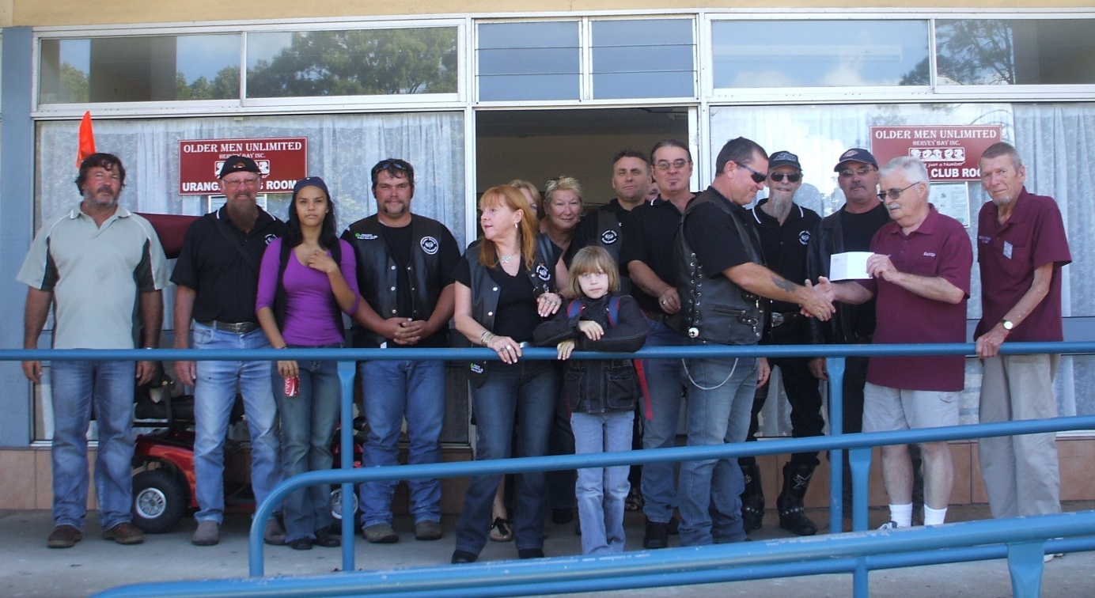

Poker Hand Winners.. ☺

1st Lin O. $500.00

2nd Graeme W. $150.00

3rd Jack I. $50.00

|  |  |  |  |  |  |
| --- | --- | --- | --- | --- | --- |
| **Expenses** | |  |  |  |  |
|  | **Total Expenses** | **$2,088.58** |  |  |  |
|  |  |  |  |  |  |
|  |  |  |  |  |  |
| **Income** |  |  |  |  |  |
|  | **Total Income** | **5,667.80** |  |  |  |
|  |  |  |  |  |  |
|  |  |  |  |  |  |
|  | **Net Profit** | **3,579.22** |  |  |  |
|  |  |  |  |  |  |
|  | **Division** |  |  |  |  |
| Spina Bifida Queensland | | $1,789.61 |  |  |  |
| Older Men Unlimited | | 1,789.61 |  |  |  |
|  | **Total** | **3,579.22** |  |  |  |

**Winner of The $500 Alcohol Raffle.** The winner of, The $500 Alcohol Raffle, Matthew Beck. Ticket No. 114. Congratulations Matthew. Matthew was at The Aussie Hotel to receive his prize. See pictures below.

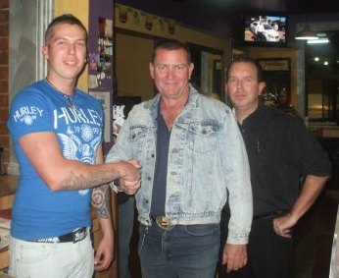 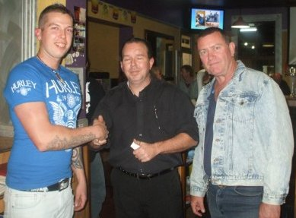

|  |  |
| --- | --- |
| **From Left. Matthew, Mark (FCSR President), and Sam (Aussie)** | **From Left. Matthew, Sam (Aussie) and Mark (FCSR President)** |

**Poker Run Summary**

Thankyou to all those who attend and contributed to this great day, with excellent company and almost perfect weather. Around 70 bikes and 7 cars/vans departed The Aussie Hotel at 9.30am on Saturday with more pikes and registrations collected along the way Mainly Apple Tree Creek and Kilkivan bringing total bikes over the day to around 80. Fraser Coast Social Riders member and Mayor of Fraser Coast attended the opening of this event.

There were no major issues except one know breakdown and disappointment with dinner on the night, something that will not occur next year. No’s were slightly down from last years event (prior to reforming), however considering our association has only existed a few months we are extremely pleased with the results and look forward to an even bigger event in 2012.

Fraser Coast Social Riders were also pleased to present Bill Shead from Spina Bifida Qld with a cheque for $1471.00, from money raised from Friday night raffles over the last 2½ months. Raffles are held at The Aussie Hotel each Friday night between 5 and 7pm, this is also a great time to socialise and make new friends. Guests are more than welcome.

**Thankyous**

Thankyou to all the pubs we visited, a special thankyou to Goomeri Grand Hotel for their hospitality input to future events in 2011 and 2012. Thankyou to all our sponsors for 2011, without their help this would not have been such a great success. Thankyou to those businesses who have already pledged support for other events in 2011/2012.

Thankyou to Tom and Barb and other Southern Cross members from Brisbane as well as the Southern Cross contingent from Capricorn Coast