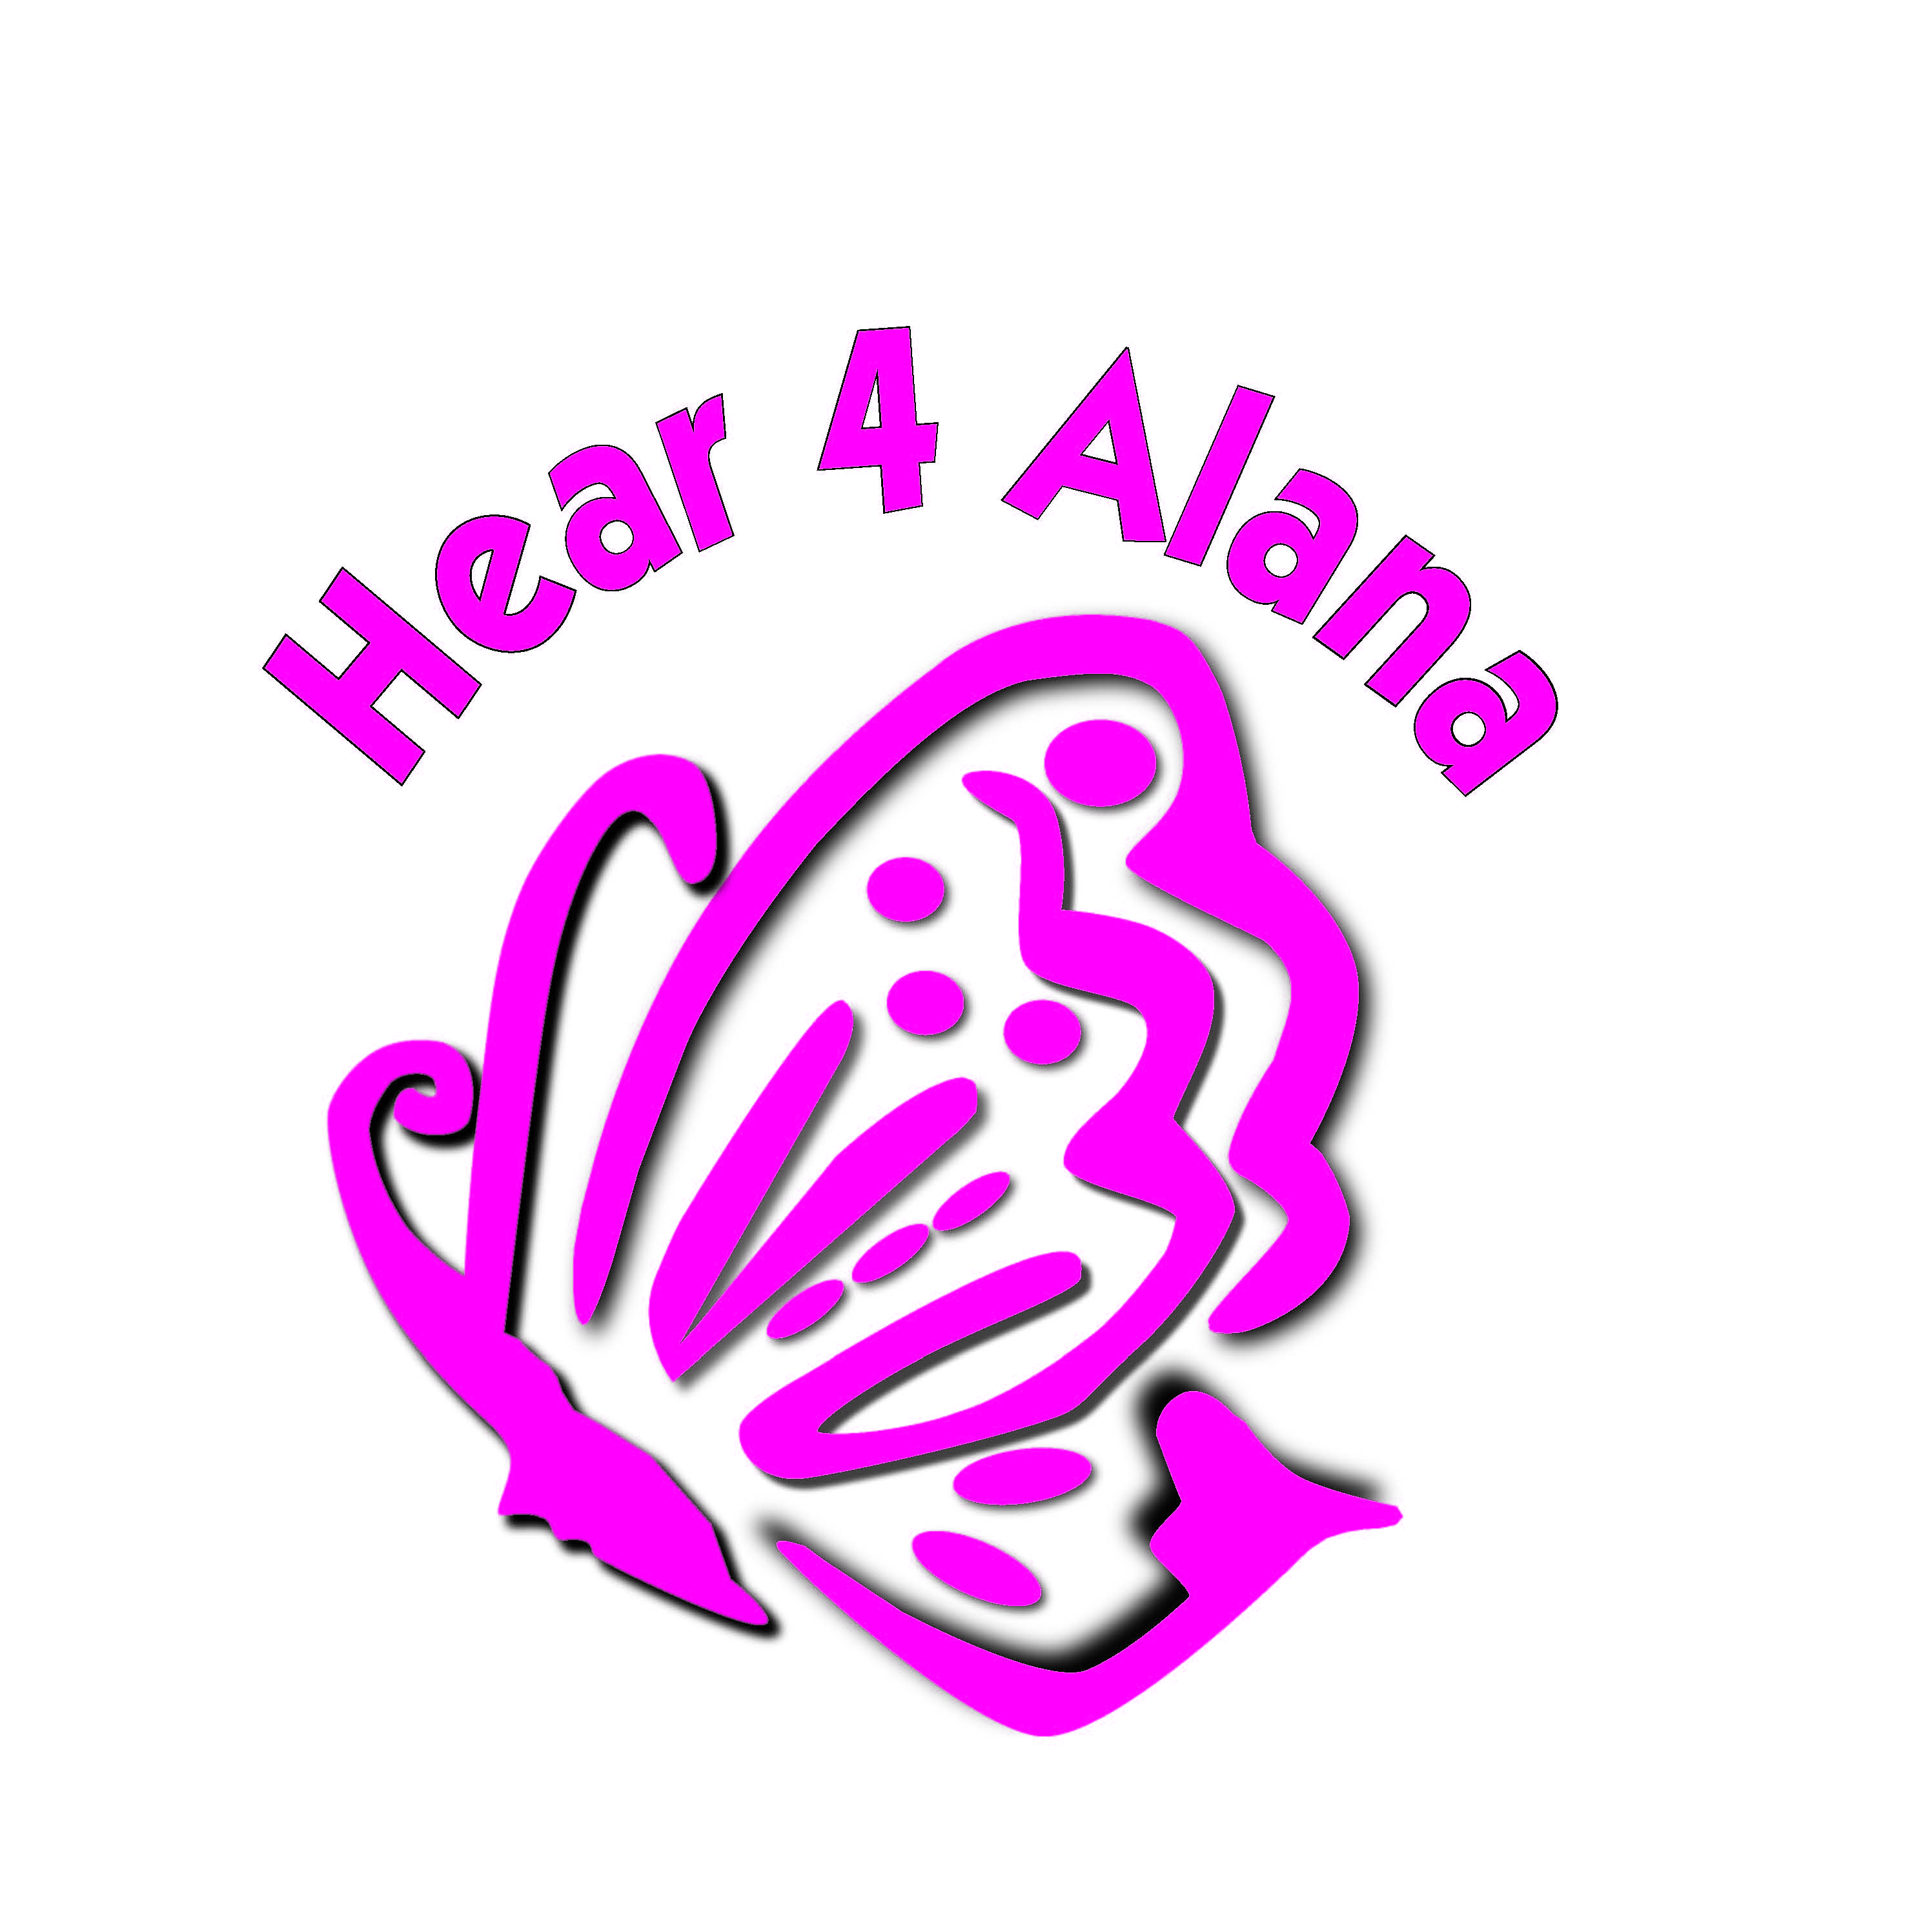

Hear 4 Alana
338 Elliot Heads Road
Bundaberg QLD 4655
Ph: 0438 338 313a
emmalinecreid@gmail.com
 www.facebook.com/Hear4Alana
Registered charity# CP5652

Our daughter Alana was born on September 11 2008. My husband and I were so excited, a little sister for our son Bailey. We noticed her right ear was quite small, but were assured that it would probably grow with Alana. The next day Alana had her newborn screening test, which resulted in a “refer” for both ears.
We went home devastated that our little girl could not hear us. We thought no, it can’t be right – we have no family history.
One week later we received a call from the hospital to bring Alana in asap – I recall being at the hairdresser, and trying to hold it together, while they hurried my appointment along.

We took Alana back to the hospital were the doctors told us that there is a problem with her thyroid function and further test must be carried out, but would start her on thyroxine to start with. The next day she was injected with radiation to have a nuclear scan of her full body. This showed she had an absent thyroid gland. The doctors kept Alana in hospital for a few days for more tests.

At four weeks of age Alana was not gaining weight at a normal rate and just seemed to sleep her days and nights away.
We returned to hospital where we were transferred to Royal Children’s Hospital Brisbane. We stayed for over a week for testing.
All was confirmed – Alana had failure to thrive, an ASD in her heart, kidney reflux, an absent thyroid gland, bilateral conductive hearing loss and microtia of her right ear and narrowing of bilateral ear canals – which we then found out, would not grow any bigger on there own.
We went home relieved we had results, but upset and angry that our little darling could not hear as.

Christmas Eve 2008 Alana was fitted with a bone conduction hearing aid at Australian Hearing Brisbane, which she wears on a soft head band.
At four months of age I contacted the Hear and Say centre in Brisbane, where Alana was then enrolled for fortnightly lessons and assessments.
Alana is seen on a regular basis by a group of specialist doctors at RCHB. Her cardiologist has advised Alana may need heart surgery in the future, and we constantly have to monitor her kidneys, T4 and TSH levels through the paediatric and endocrine team. Along the way new problems have appeared, last year Alana had to have her teeth capped in silver as she has an enamel deficiency, without the capping Alana’s teeth would have ground away.

Each year for the past three years we have attended the microtia and atresia conference held on the Gold Coast and Brisbane where specialist in this field from USA have seen Alana and given us hope that her hearing may be fixed, and they can even give her corrective surgery using a new medpor technique to correct the outer ear, and widen her ear canals to correct the hearing. The doctors have advised this surgery should be performed prior to her heart surgery.
We have spoken with other families, who have children that had microtia and visited the USA, we have contemplated and researched this decision for three years and have now decided that this surgery is what we feel is best for our little girl. We want her to reach her full potential in life and she may have been born with a lot of different congenital problems, but we're hoping to fix what we can, to make her life easier, without the burden of looking and feeling different.
To have this surgery for Alana is the best option, and this does come at a high price, $97,000 is what we need to raise to cover the cost, as it is not covered by Medicare or any private health insurance.
We are hoping to fundraise some of the costs of the surgery and trip. We would truly appreciate any assistance you can offer us to make our dream for our little girl become a reality.

Thankyou for your time in considering our request

Shane and Emma Reid

